- Account & HR Management
Diagram Type: Activity Diagram (Swimlane)

Grouped Requirements:
Retail Customer creates a personal checking account
Corporate Customer initiates bulk payroll processing
Corporate Customer manages multiple authorized signers
Personal Banker updates KYC (Know Your Customer) documents
Personal Banker issues a new debit card
HR Manager creates system user accounts for new staff
HR Manager revokes system access for terminated employees
HR Manager assigns the new employee their system roles
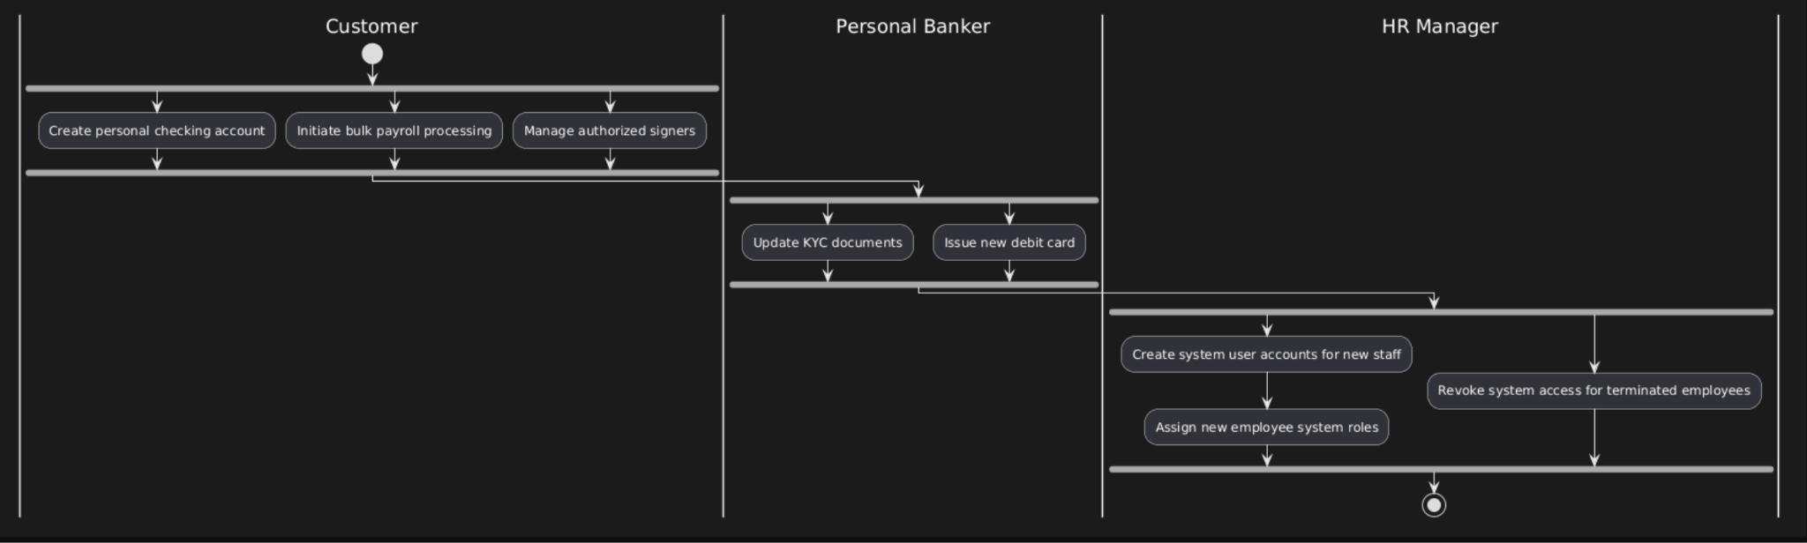

- Transaction & Cash Operations
Diagram Type: Activity Diagram (Swimlane)

Grouped Requirements:
Bank Teller initiates a cash deposit during a shift
Bank Teller processes a standard withdrawal
External Payment Gateway settles external transfers via the clearing house
Assistant Branch Manager inspects teller drawers
Assistant Branch Manager approves moderate-value transaction overrides
Branch Manager authorizes extreme transaction overrides
Branch Manager approves the daily vault cash balance
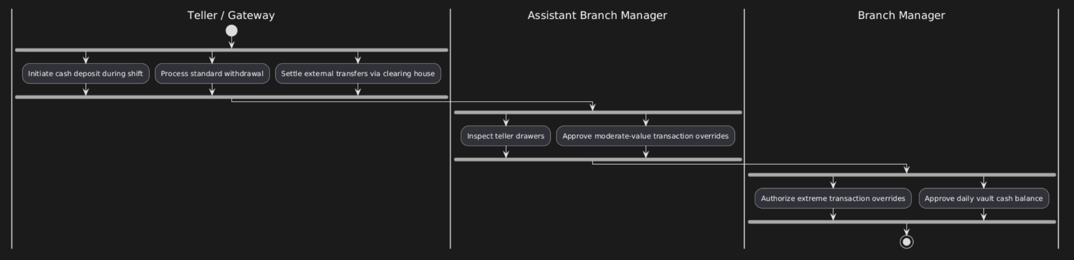

- Loan & Credit Processing
Diagram Type: Activity Diagram (Swimlane)

Grouped Requirements:
Retail Loan Officer evaluates standard mortgage applications
Corporate Credit Analyst evaluates complex business financials
The underwriter analyzes system-generated risk scores
Underwriter binds the bank legally to a loan agreement
Collections Officer structures repayment plans for defaulted accounts
Collections Officer initiates asset recovery
Chief Risk Officer sets global risk parameters for automated flagging

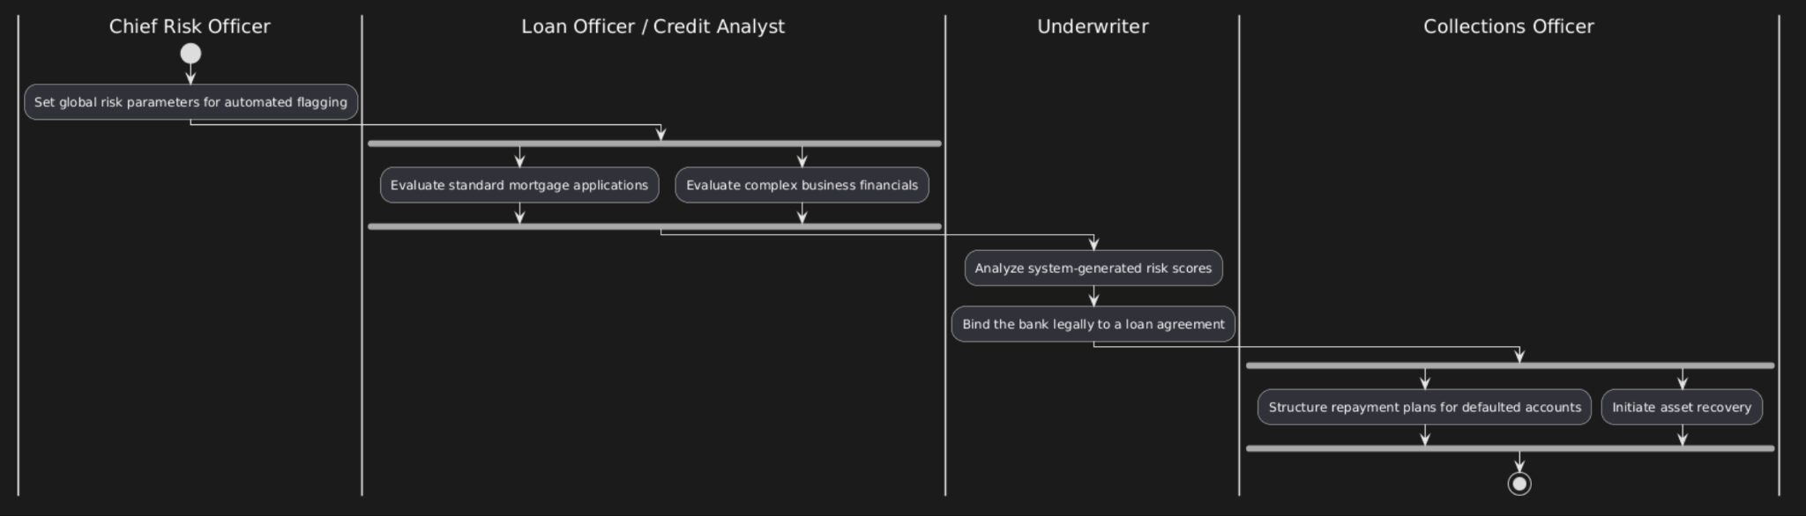

- Monitoring, Security & Admin
Diagram Type: Activity Diagram (Swimlane)

Grouped Requirements:
AML/KYC Officer monitors high-frequency international transactions
AML/KYC Officer can generate reports with a specific structure designed only for reports sent to government regulatory bodies
Internal Auditor views employee action history logs
Regional Director views collected and summarized profitability data across branches
System Administrator changes the baseline interest rate globally
Security Administrator manages system encryption keys
Database Administrator executes automated database backups

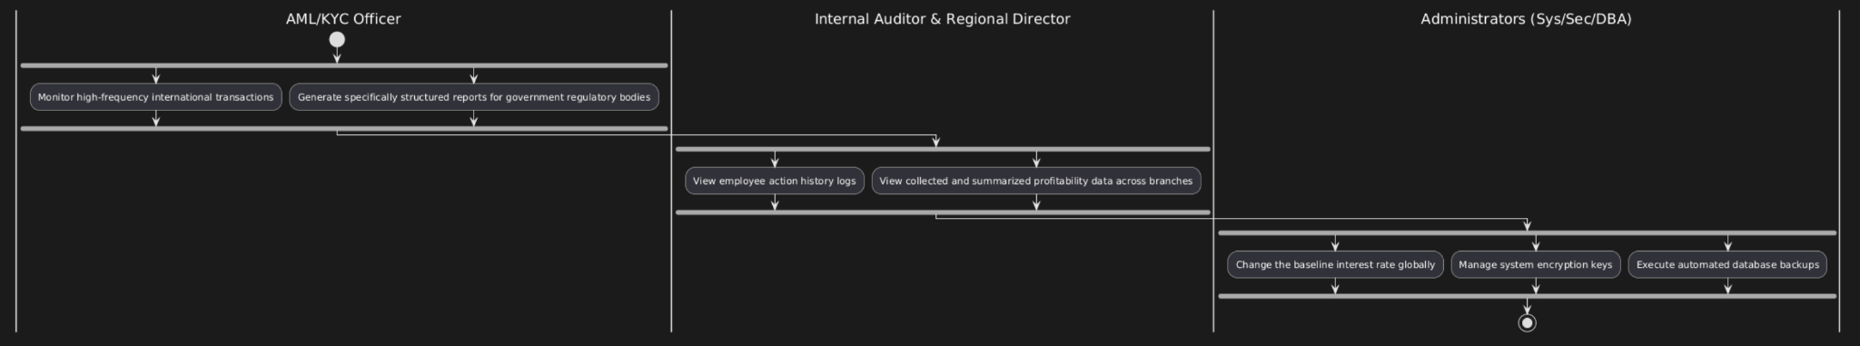

- Automated System Processes
Diagram Type: Activity Diagram (System Flow)

Grouped Requirements:
System updates ledger balances in real-time
System routes loan requests to the Manager’s dashboard
System schedules automated Equated Monthly Installment (EMI) payments
System generates date-filtered account statements
System records an immutable audit trail of the "who, what, and when"
System authenticates users via secure login credentials
System flags dangerous loans based on Chief Risk Officer (CRO) parameters
System notifies the AML officer of suspicious activity
System generates daily transaction summaries for managers

6. Bank Account Lifecycle
Diagram Type: State Diagram

Why this type: While activity diagrams show actions, state diagrams show the condition of a database entity. A bank account's status dictates what can happen to it. This diagram is required so backend developers know exactly what the database enums are (Pending, Active, Suspended, Closed) and what rules govern moving an account from one state to another (e.g., AML flagging triggers a "Suspended" state).

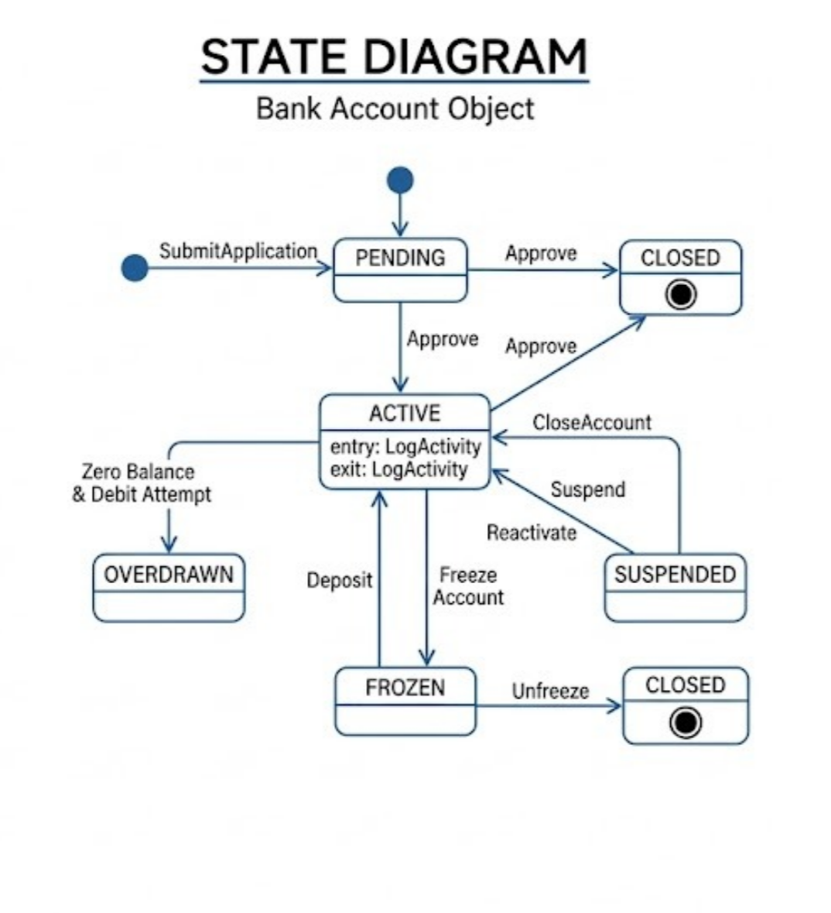

7. Loan Application Lifecycle
Diagram Type: State Diagram

Grouped Requirements:
This represents the states implied by the Loan & Credit Processing requirements (e.g., evaluation, underwriting, binding, default, and recovery)

